Estonia

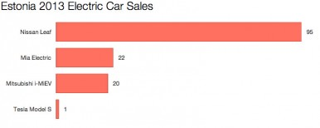

Estonia may not be the first country that comes to mind when you think of electric cars, but the small Eastern European nation was actually the first country in the world to install a [nationwide network of electric vehicle fast chargers](http://cleantechnica.com/2013/02/23/estonia-is-1st-country-in-the-world-to-install-nationwide-system-of-fast-chargers-for-evs/) (with great help from ABB, of course). [ABB won the tender for that project](http://www.abb.ie/cawp/seitp202/d07e075541462e04c125798000353578.aspx) in January 2012. Anyway, getting to sales, the Nissan Leaf again dominated this small market. It took home 69% of the pie through its 95 sales. Two small vehicles—the Mia Electric and the Mitsubishi i-MiEV—sold 22 and 20 cars, respectively. And there was one Tesla Model S sold in Estonia in 2013.